Test plan for
serveu

ChangeLog

Version | Change Date | By | Description
version number 0.1 | 30.10.23 | Md Faizal | Description of the changes made

1 Introduction 2
1.1 Scope 2
1.1.1 In Scope 2
1.1.2 Out of Scope 2
1.2 Quality Objective 2
1.3 Roles and Responsibilities 2
2 Test Methodology 3
2.1 Overview 3
2.2 Test Levels 3
2.3 Bug Triage 3
2.4 Suspension Criteria and Resumption Requirements 3
2.5 Test Completeness 4
3 Test Deliverables 4
4 Resource & Environment Needs 4
4.1 Testing Tools 4
4.2 Test Environment 4
5 Terms/Acronyms 5

Introduction

In an era characterized by rapid technological advancements and ever-increasing demands on our time, individuals, especially bachelors, often find themselves struggling to efficiently manage essential services essential to daily life. Tasks like cook/chef, grocery shopping, and cleaning, once mundane, have become time-consuming challenges, often resulting in wasted hours, frustration, and subpar experiences. The difficulties lie in the arduous process of finding reliable service providers, comparing prices, and coordinating bookings, leading to a pressing need for a solution that simplifies and streamlines this experience.
This research paper delves into the innovative realm of mobile application technology, presenting a comprehensive and user-friendly solution to the daily challenges faced by bachelors. By leveraging cutting-edge technologies, this project aims to develop a robust mobile application that revolutionizes the way individuals access and manage essential services. This application does not merely serve as a platform for connecting users with service providers; it is a transformative tool designed to enhance efficiency, reliability, and convenience in the daily lives of bachelors.
Throughout this paper, we will explore the intricacies of this groundbreaking mobile application. From its foundational technologies to its user-friendly interface, the research will provide a detailed analysis of the application’s architecture, design principles, and implementation strategies. We will also examine the challenges faced by bachelors in accessing essential services and how the proposed application addresses these pain points. Moreover, this paper will shed light on the project’s impact on user experience, scalability, and data security, contributing valuable insights to the burgeoning field of mobile application development.
In essence, this research paper serves as a comprehensive exploration of a transformative solution, one poised to significantly enhance the quality of life for bachelors, offering them a streamlined, reliable, and efficient way to manage their essential services. Through a meticulous examination of technology integration, user experience, and real-world applicability, this paper aims to present not only a solution but a paradigm shift in how we approach the challenges of our daily lives in an increasingly digital world.

Scope

In Scope

Scope defines the features, functional or non-functional requirements of the software that will be tested

1. All Required field should be entered
2. Only grocery items should be checked
3. Location should be enabled or not, whether it is taking the write location or not .
4. Check whether the filter feature is working or not .
5. Check whether the sorting feature is working or not .

Out of Scope

Out Of Scope defines the features, functional or non-functional requirements of the software that will NOT be tested

Quality Objective

Here make a mention of the overall objevtie that you plan to achive withou your testing

Some objectives of your testing project could be

- Ensure the Application Under Test conforms to functional and non-functional requirements
- Ensure the AUT meets the quality specifications defined by the client
- Bugs/issues are identified and fixed before go live

Roles and Responsibilities
Detail description of the Roles and responsibilities of different team members like
- QA Analyst- Md. Faizal
The Quality Assurance (QA) Analyst conducted testing on software, websites, and other technical products to identify and resolve bugs, defects, and other potential issues.
- Test Manager –Professor Abhishek Goyal
- Configuration Manager – Akansha mam
- Developers – Md.Faizal , Manish Kumar , Harsh Chaudhary
- Installation Team - Md.Faizal , Manish Kumar
Amongst others

Test Methodology

Overview

Step 1: Market Research and User Needs Analysis
1.1 Identify Target Audience:
Conducted surveys and interviews with bachelors to understand their specific needs and pain points.
Identified the most essential services that bachelors require, such as grocery shopping, cleaning, etc.

Step 2: Defining Features and Functionalities
2.1 Essential Features:
User registration and profiles.
Service provider listings with detailed profiles and reviews.
Service booking and scheduling.
In-app chat or communication platform
GPS integration for service provider location and tracking.
Service history and reviews for both users and providers.
Push notifications for bookings, confirmations, and reviews.
2.2 Additional Features (Differentiators):
Integration with third-party APIs for real-time service provider availability.
Multi-platform availability (iOS, Android, Web).
Step 3: App Development
3.1 Frontend Development:
Develop an intuitive user interface (UI) focusing on simplicity and ease of use.
Implemented responsive design for various devices and screen sizes using React , Sass and CSS.
Created service provider profiles with necessary details and high-quality images.
3.2 Backend Development:
Set up a robust backend server using NodeJS to handle user data, service provider information, bookings.
Implemented a database using MongoDB to store user profiles, service provider details, and transaction history.
Develop algorithms for matching users with suitable service providers based on their requirements and location.
Quality Assurance and Testing
4.1 Functional Testing:
Tested all features and functionalities to ensure they work as intended using Jest.
4.2 Performance Testing:
Test the app's performance under different network conditions and device specifications.
Optimize loading times and ensure smooth user experience.

Test Levels

Test Levels define the Types of Testing to be executed on the Application Under Test (AUT). The Testing Levels primarily depends on the scope of the project, time and budget constraints.

Bug Triage

The goal of the triage is to

- To define the type of resolution for each bug
- To prioritize bugs and determine a schedule for all “To Be Fixed Bugs’.

ID | Date Reported | Reported By | Severity | Status | Assigned To | Description | Steps to Reproduce | Expected Result | Actual Result | Attachments
1 | 2023-11-01 | John | High | Open | Dev Team | Unable to login | 1. Open the app. 2. Click on Login. 3. Enter valid credentials. | User should be logged in successfully. | Error message: "Invalid username or password." | Screenshot
2 | 2023-11-02 | Alice | Medium | In Progress | QA Team | Service search results not updating | 1. Enter location and service type. 2. Click Search. 3. Change location while search is in progress. | Search results should be based on the updated location. | Search results still show old location's services. | Video Recording
3 | 2023-11-03 | Bob | Low | Closed | N/A | Typo in service description | 1. Navigate to service details page. 2. Read service description. | Description should be grammatically correct. | Typo in the word "availabe." | None
4 | 2023-11-04 | Mary | High | Open | Dev Team | Payment processing error | 1. Book a service. 2. Proceed to payment. 3. Enter valid payment details. 4. Click Pay. | Payment should be processed, and booking confirmed. | Error message: "Transaction failed, please try again later." | Error log
5 | 2023-11-05 | Sam | Critical | In Progress | Dev Team | App crashes on startup | 1. Open the app.

Suspension Criteria and Resumption Requirements

Suspension criteria define the criteria to be used to suspend all or part of the testing procedure while Resumption criteria determine when testing can resume after it has been suspended

Test Completeness
Here you define the criterias that will deem your testing complete.
For instance, a few criteria to check Test Completeness would be
- 100% test coverage
- All Manual & Automated Test cases executed
- All open bugs are fixed or will be fixed in next release

Test Deliverables

Here mention all the Test Artifacts that will be delivered during different phases of the testing lifecycle.

Frontend Test:
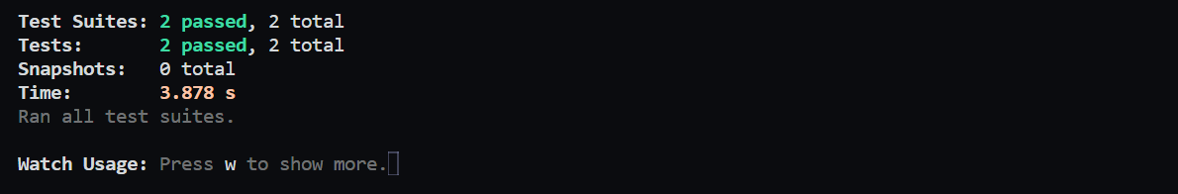

End To End testing:
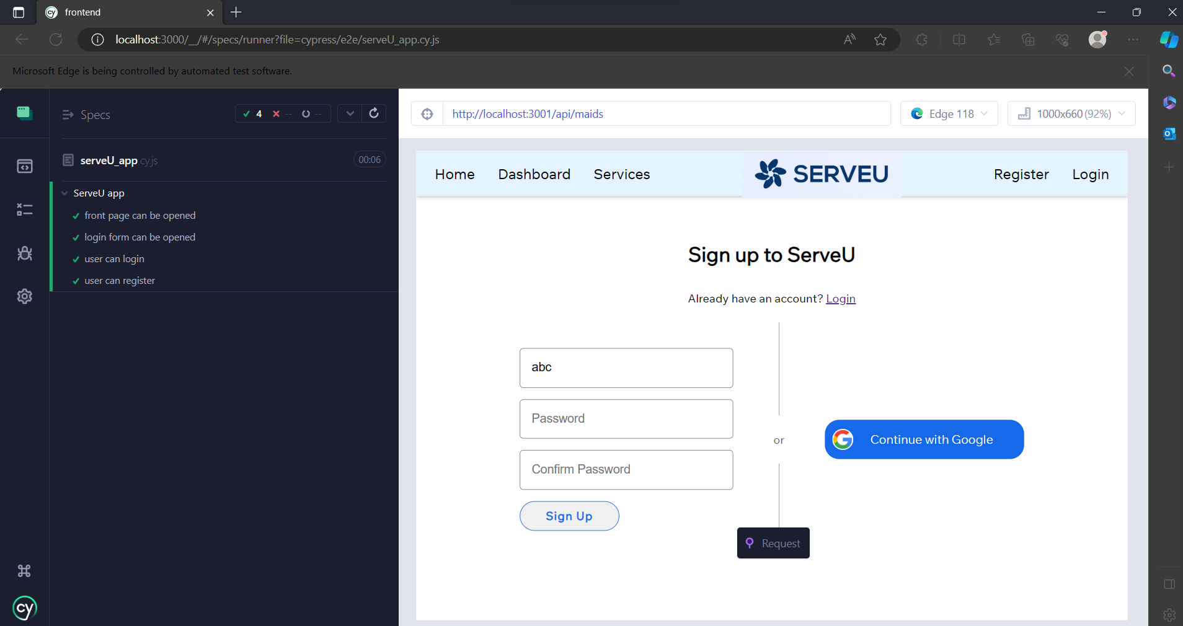

APIs Testing:

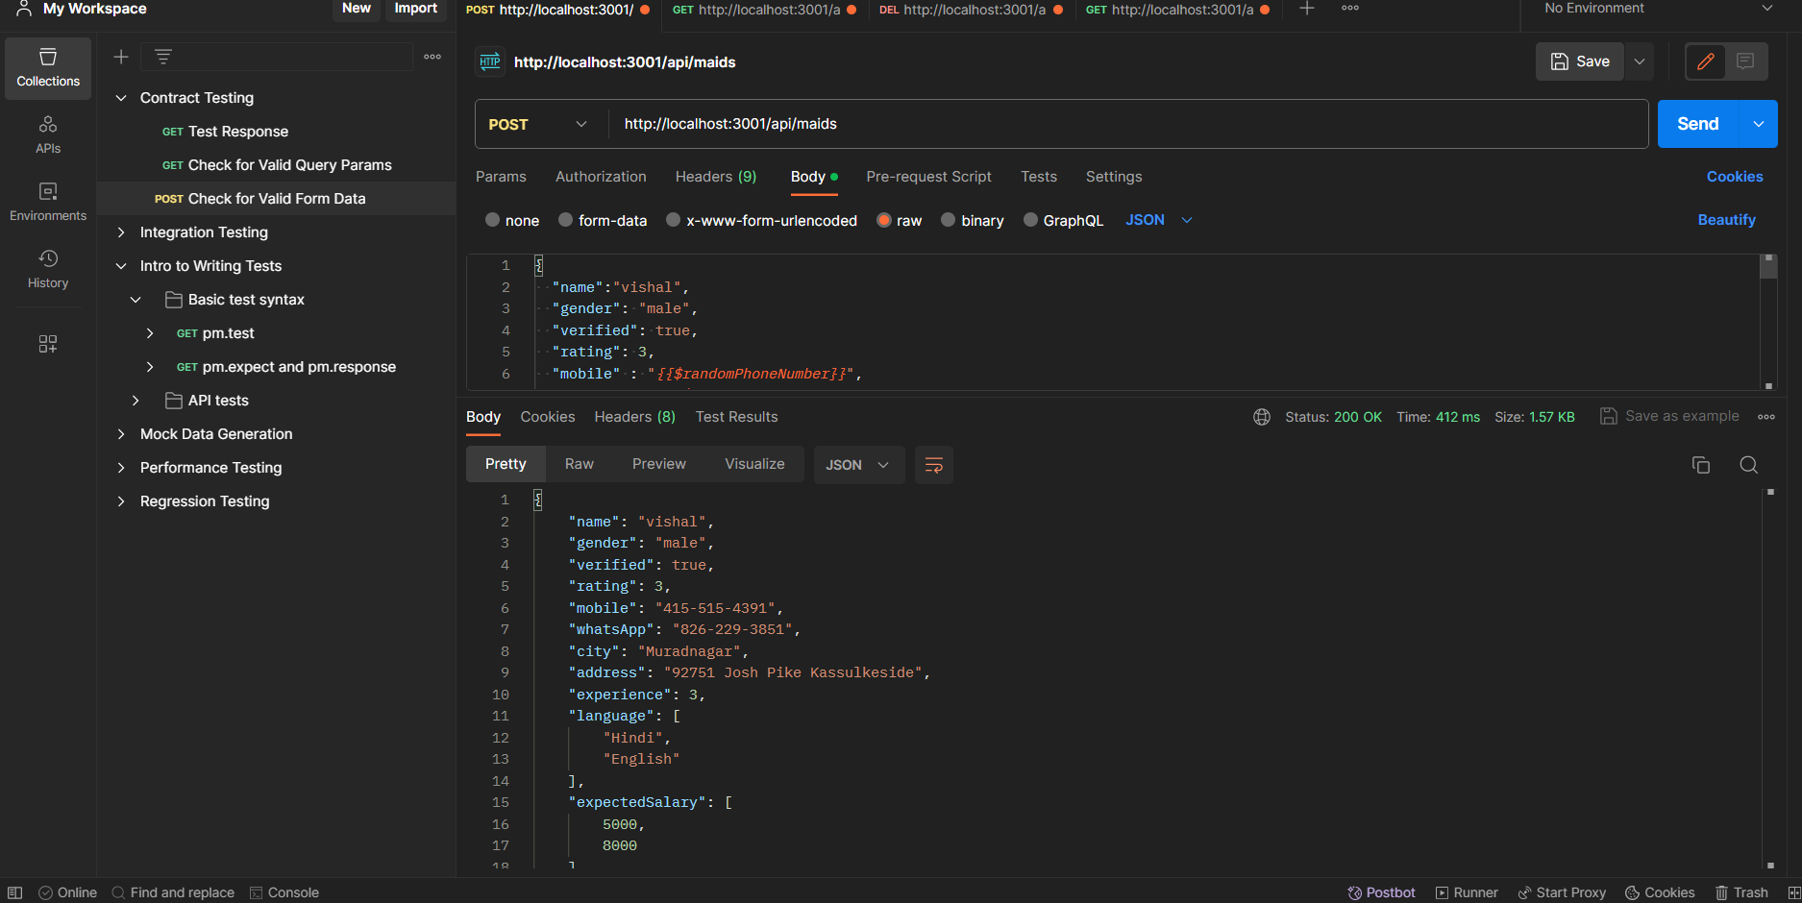

Here are the sample deliverables
- Test Plan
- Test Cases
- Requirement Traceability Matrix
- Bug Reports
- Test Strategy
- Test Metrics
- Customer Sign Off

Resource & Environment Needs

Testing Tools

list of Tools like
- Requirements Tracking- Tool Postman
- Bug Tracking Tool
- Automation Tools
Required to test the project

Test Environment
It mentions the minimum hardware requirements that will be used to test the Application.

Following software’s are required in addition to client-specific software.

- Windows 8 and above
- Office 2013 and above
- MS Exchange, etc.

Terms/Acronyms
Make a mention of any terms or acronyms used in the project

TERM/ACRONYM | DEFINITION
API | Application Program Interface
AUT | Application Under Test

